Point on a Ray

Definition
# Source: AI Source: Provided by: [Data Path: Persons Table -> ID Column: 1, Name_En Column: Motasem Essam] -> From: [ChatGPT] on [7/25/2026]
A Point on a Ray is a point that lies on the infinite straight path that begins at an endpoint and extends infinitely in one direction.
If ray $\vec{AB}$starts at $A$and passes through $B$, then a point $P$is on the ray if it lies on the line through $A$and $B$and is located at $A$or beyond $A$in the direction from $A$toward $B$.
The containment relationship is written as:
$$P∈\vec{AB}$$
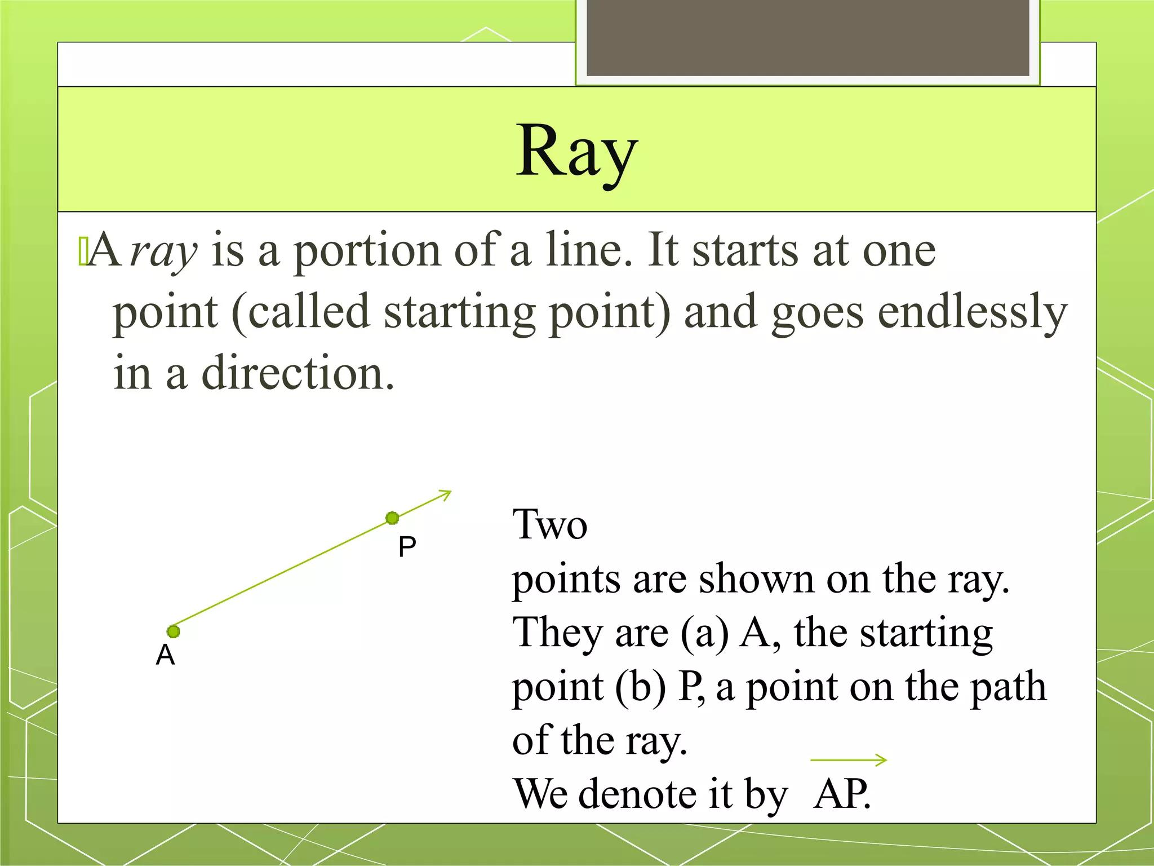
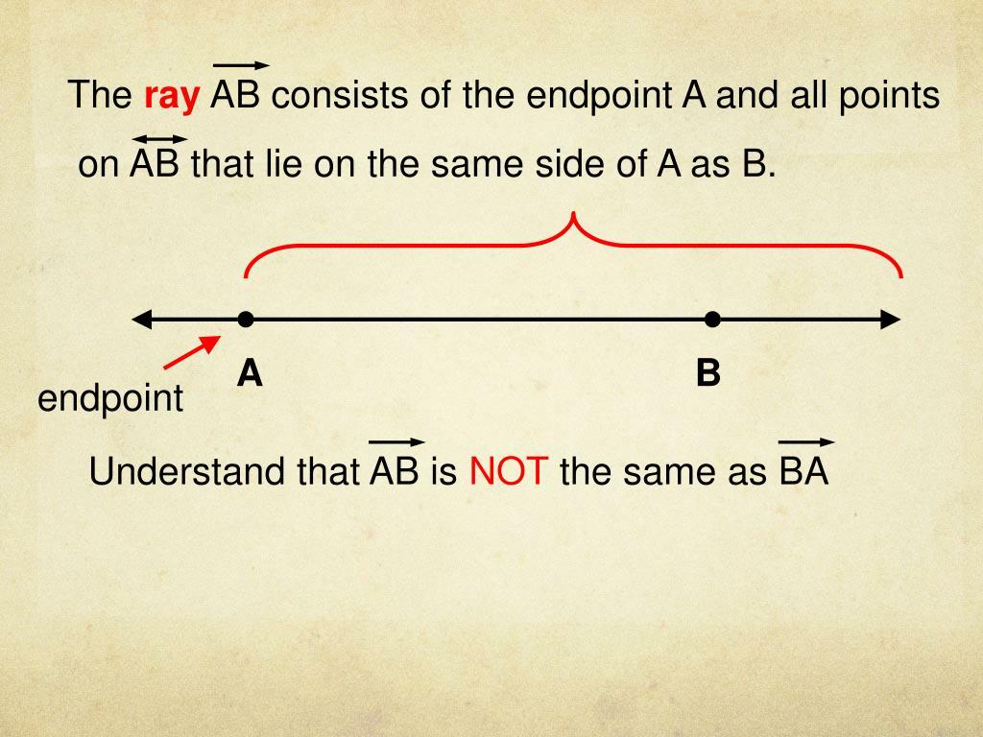
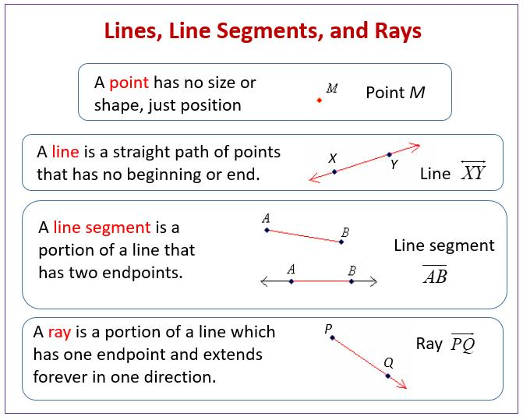
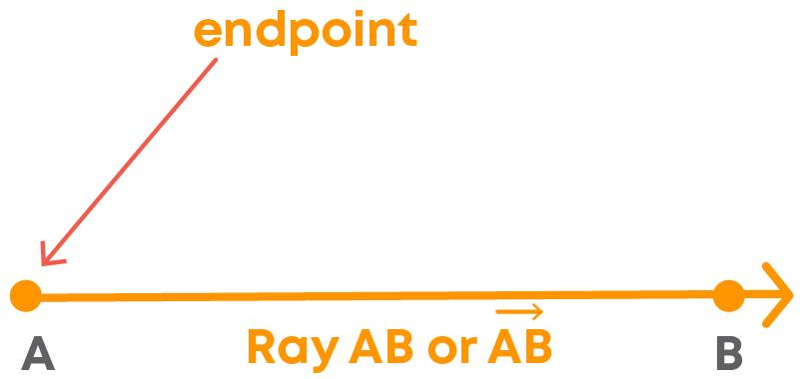

Fundamental Concept
# Source: AI Source: Provided by: [Data Path: Persons Table -> ID Column: 1, Name_En Column: Motasem Essam] -> From: [ChatGPT] on [7/25/2026]
A ray has:
- One endpoint
- Infinitely many points
- One fixed direction
- No endpoint at the direction in which it extends
For ray $\vec{AB}$:
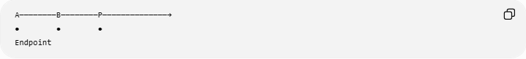
A────────B────────P──────────────→
● ● ●
Endpoint
- $A$is the endpoint.
- $B$is a point defining the direction.
- $P$is another point on the ray.
- The ray continues indefinitely beyond $P$.
Therefore:
$$A∈\vec{AB} \\ B∈\vec{AB} \\ P∈\vec{AB}$$

Mathematical Representation
# Source: AI Source: Provided by: [Data Path: Persons Table -> ID Column: 1, Name_En Column: Motasem Essam] -> From: [ChatGPT] on [7/25/2026]
A ray beginning at point $A$and passing through $B$can be represented as:
$$\vec{AB}$$
A point $P$belongs to this ray when it can be written as:
$$P=A+t\left(B-A\right), t≥0$$
where $t$determines the position of $P$.
Interpretation of $t$

Value of $t$ | Position
$$t=0$$ | $P=A$, the endpoint
$$0<t<1$$ | $P$lies between $A$and $B$
$$t=1$$ | $$P=B$$
$$t>1$$ | $P$lies beyond $B$
$$t<0$$ | $P$is not on ray $\vec{AB}$
Thus:
$$\boxed{P∈\vec{AB} ⟺ P=A+t\left(B-A\right), t≥0}$$

Fundamental Elements

1. Endpoint
# Source: AI Source: Provided by: [Data Path: Persons Table -> ID Column: 1, Name_En Column: Motasem Essam] -> From: [ChatGPT] on [7/25/2026]
The endpoint is the point where the ray begins.
For $\vec{AB}$:
$$A=\text{endpoint}$$
The endpoint belongs to the ray.

2. Direction Point
# Source: AI Source: Provided by: [Data Path: Persons Table -> ID Column: 1, Name_En Column: Motasem Essam] -> From: [ChatGPT] on [7/25/2026]
Point $B$establishes the direction of the ray.
The notation
$$\vec{AB}$$
means:
Start at $A$and travel through $B$, continuing indefinitely.
Reversing the letters changes the ray:
$$\vec{AB}≠\vec{BA}$$
in general.

3. Infinite Extension
# Source: AI Source: Provided by: [Data Path: Persons Table -> ID Column: 1, Name_En Column: Motasem Essam] -> From: [ChatGPT] on [7/25/2026]
The ray continues forever in one direction:
A────────B────────P──────────────→
● ● ●
There is no final endpoint on the right.

4. Points on the Ray
# Source: AI Source: Provided by: [Data Path: Persons Table -> ID Column: 1, Name_En Column: Motasem Essam] -> From: [ChatGPT] on [7/25/2026]
Every point located on the ray in its direction from $A$belongs to the ray.
For example:
$$A,B,P,Q∈\vec{AB}$$
if they are positioned in the correct order along the ray.

How to Determine Whether a Point Is on a Ray
# Source: AI Source: Provided by: [Data Path: Persons Table -> ID Column: 1, Name_En Column: Motasem Essam] -> From: [ChatGPT] on [7/25/2026]
To determine whether $P$lies on $\vec{AB}$, two conditions must be satisfied:
Condition 1: Collinearity
The points $A$, $B$, and $P$must lie on the same line.
Condition 2: Correct Direction
$P$must lie at $A$or in the direction from $A$through $B$.
Therefore:
$$P∈\vec{AB}$$
requires both:
$$A,B,P\text{ are collinear}$$
and
$$P\text{ is not behind }A\text{ relative to }B.$$

Coordinate Representation
# Source: AI Source: Provided by: [Data Path: Persons Table -> ID Column: 1, Name_En Column: Motasem Essam] -> From: [ChatGPT] on [7/25/2026]
Suppose:
$$A=\left(x_{1} , y_{1}\right)$$
and
$$B=\left(x_{2} , y_{2}\right).$$
The ray can be represented parametrically as:
$$\left(x , y\right)=\left(x_{1} , y_{1}\right)+t\left(x_{2} , -x_{1}y_{2}-y_{1}\right), t≥0$$
or:
$$x=x_{1}+t\left(x_{2}-x_{1}\right) \\ y=y_{1}+t\left(y_{2}-y_{1}\right)$$
with:
$$t≥0.$$
A point satisfying these equations belongs to the ray.

Examples

Example 1: Point Between the Endpoint and Direction Point
# Source: AI Source: Provided by: [Data Path: Persons Table -> ID Column: 1, Name_En Column: Motasem Essam] -> From: [ChatGPT] on [7/25/2026]
Let:
$$A=\left(1 , 2\right), B=\left(5 , 2\right)$$
and:
$$P=\left(3 , 2\right).$$
The points are collinear:
$$A→P→B$$
and $P$lies in the direction from $A$through $B$.
Therefore:
$$\boxed{P∈\vec{AB}}$$

Example 2: Point Beyond $B$
# Source: AI Source: Provided by: [Data Path: Persons Table -> ID Column: 1, Name_En Column: Motasem Essam] -> From: [ChatGPT] on [7/25/2026]
Let:
$$A=\left(1 , 2\right), B=\left(5 , 2\right)$$
and:
$$P=\left(9 , 2\right).$$
The order is:
A────B────P────────→
Although $P$is beyond $B$, the ray continues indefinitely.
Therefore:
$$\boxed{P∈\vec{AB}}$$

Example 3: Endpoint
# Source: AI Source: Provided by: [Data Path: Persons Table -> ID Column: 1, Name_En Column: Motasem Essam] -> From: [ChatGPT] on [7/25/2026]
Let:
$$A=\left(2 , 3\right)$$
be the endpoint of $\vec{AB}$.
Because the endpoint belongs to the ray:
$$\boxed{A∈\vec{AB}}$$

Example 4: Point Behind the Endpoint
# Source: AI Source: Provided by: [Data Path: Persons Table -> ID Column: 1, Name_En Column: Motasem Essam] -> From: [ChatGPT] on [7/25/2026]
Consider:
$$A=\left(1 , 2\right), B=\left(5 , 2\right)$$
and:
$$P=\left(- , 22\right).$$
All three points are collinear, but their order is:
P────A────B────────→
The ray begins at $A$and extends toward $B$, so $P$is behind the endpoint.
Therefore:
$$\boxed{P∉\vec{AB}}$$
This is an important distinction: being on the supporting line does not necessarily mean being on the ray.

Vector Test
# Source: AI Source: Provided by: [Data Path: Persons Table -> ID Column: 1, Name_En Column: Motasem Essam] -> From: [ChatGPT] on [7/25/2026]
For:
$$\vec{AB}$$
a point $P$is on the ray when:
$$\vec{AP}=t\vec{AB}$$
for some:
$$t≥0.$$
For example:
$$A=\left(1 , 2\right), B=\left(5 , 2\right), P=\left(9 , 2\right)$$
gives:
$$\vec{AB}=\left(4 , 0\right)$$
and:
$$\vec{AP}=\left(8 , 0\right).$$
Thus:
$$\vec{AP}=2\vec{AB}$$
so:
$$t=2≥0.$$
Therefore:
$$P∈\vec{AB}.$$

Point on a Ray vs Point on a Line Segment
# Source: AI Source: Provided by: [Data Path: Persons Table -> ID Column: 1, Name_En Column: Motasem Essam] -> From: [ChatGPT] on [7/25/2026]
This distinction is fundamental.
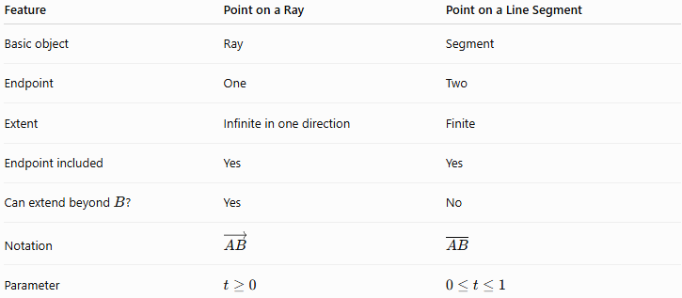
Feature | Point on a Ray | Point on a Line Segment
Basic object | Ray | Segment
Endpoint | One | Two
Extent | Infinite in one direction | Finite
Endpoint included | Yes | Yes
Can extend beyond $B$? | Yes | No
Notation | $$\vec{AB}$$ | $$\overset{‾}{AB}$$
Parameter | $$t≥0$$ | $$0≤t≤1$$
For the same $A$and $B$:
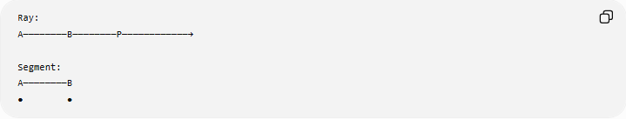
Ray:
A────────B────────P────────────→

Segment:
A────────B
● ●
For a segment:
$$P=A+t\left(B-A\right), 0≤t≤1$$
while for a ray:
$$P=A+t\left(B-A\right), t≥0.$$

Point on a Ray vs Point on a Line
# Source: AI Source: Provided by: [Data Path: Persons Table -> ID Column: 1, Name_En Column: Motasem Essam] -> From: [ChatGPT] on [7/25/2026]
A line extends infinitely in both directions:
←────────A────────B────────P────────→
A ray extends infinitely in one direction:
A────────B────────P──────────────→
Therefore, a point can lie on the supporting line but not on the ray.
For example:
$$P∈\overset{↔}{AB}$$
does not necessarily imply:
$$P∈\vec{AB}.$$

Point on a Ray vs Point on a Segment
# Source: AI Source: Provided by: [Data Path: Persons Table -> ID Column: 1, Name_En Column: Motasem Essam] -> From: [ChatGPT] on [7/25/2026]
There is an important containment relationship:
$$\boxed{\overset{‾}{AB}⊂\vec{AB}}$$
because every point of segment $\overset{‾}{AB}$is also on ray $\vec{AB}$.
Similarly:
$$\vec{AB}⊂\overset{↔}{AB}.$$
Therefore:
Line
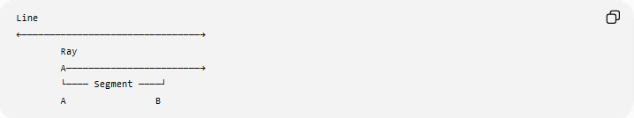
←────────────────────────────────→
Ray
A────────────────────────→
└──── Segment ────┘
A B
The relationships can be summarized as:
$$\boxed{\overset{‾}{AB}⊂\vec{AB}⊂\overset{↔}{AB}}$$

Important Property of Ray Notation
# Source: AI Source: Provided by: [Data Path: Persons Table -> ID Column: 1, Name_En Column: Motasem Essam] -> From: [ChatGPT] on [7/25/2026]
The order of the letters matters.
$$\vec{AB}$$
starts at $A$and passes through $B$.
But:
$$\vec{BA}$$
starts at $B$and passes through $A$.
For distinct $A$and $B$:
$$\boxed{\vec{AB}≠\vec{BA}}$$
because they have different endpoints and extend in opposite directions.

Relationship with Segment Addition
# Source: AI Source: Provided by: [Data Path: Persons Table -> ID Column: 1, Name_En Column: Motasem Essam] -> From: [ChatGPT] on [7/25/2026]
If $P$lies between $A$and $B$, then:
$$AP+PB=AB.$$
Since $P$is also on ray $\vec{AB}$:
$$P∈\vec{AB}.$$
However, if $P$lies beyond $B$, then:
$$AP=AB+BP.$$
The point is still on the ray:
$$P∈\vec{AB}.$$

Real-World Applications
# Source: AI Source: Provided by: [Data Path: Persons Table -> ID Column: 1, Name_En Column: Motasem Essam] -> From: [ChatGPT] on [7/25/2026]
The concept of a point on a ray is useful in:
- Navigation: a direction extending from a starting location.
- Optics: light rays traveling from a source in one direction.
- Physics: representing directed paths or trajectories.
- Computer graphics: ray casting and ray tracing.
- Robotics: representing movement from a starting position in a specified direction.
- Coordinate geometry: describing half-lines and directional regions.
- Engineering: modeling lines of sight and directional measurements.

Relationship with Related Concepts
# Source: AI Source: Provided by: [Data Path: Persons Table -> ID Column: 1, Name_En Column: Motasem Essam] -> From: [ChatGPT] on [7/25/2026]
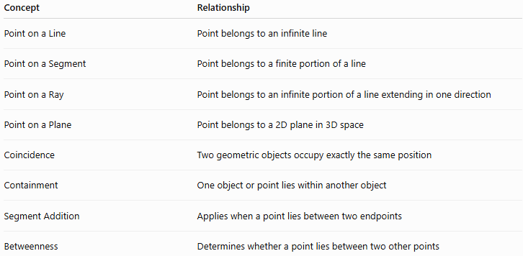
Concept | Relationship
Point on a Line | Point belongs to an infinite line
Point on a Segment | Point belongs to a finite portion of a line
Point on a Ray | Point belongs to an infinite portion of a line extending in one direction
Point on a Plane | Point belongs to a 2D plane in 3D space
Coincidence | Two geometric objects occupy exactly the same position
Containment | One object or point lies within another object
Segment Addition | Applies when a point lies between two endpoints
Betweenness | Determines whether a point lies between two other points

Key Points
# Source: AI Source: Provided by: [Data Path: Persons Table -> ID Column: 1, Name_En Column: Motasem Essam] -> From: [ChatGPT] on [7/25/2026]
- A ray has one endpoint and extends infinitely in one direction.
- A point on a ray satisfies:
$$P∈\vec{AB}.$$
- The endpoint itself belongs to the ray.
- A point can lie beyond $B$and still belong to $\vec{AB}$.
- A point behind the endpoint $A$does not belong to $\vec{AB}$.
- Collinearity alone is not sufficient; the point must also be in the correct direction.
- Parametrically:
$$P=A+t\left(B-A\right), t≥0.$$
- The containment relationship is:
$$\overset{‾}{AB}⊂\vec{AB}⊂\overset{↔}{AB}.$$
- The order of ray notation matters:
$$\vec{AB}≠\vec{BA}.$$

Conclusion
# Source: AI Source: Provided by: [Data Path: Persons Table -> ID Column: 1, Name_En Column: Motasem Essam] -> From: [ChatGPT] on [7/25/2026]
Point on a Ray describes the containment relationship in which a point belongs to a ray beginning at a specified endpoint and extending infinitely in one direction. Determining whether a point lies on a ray requires both collinearity and correct directional position. This concept provides an important foundation for understanding rays, segments, lines, betweenness, geometric containment, coordinate geometry, vectors, and directional constructions.

